

Faculty of Computer Applications
MCA Sem-1
(AY-2026-27)

Lab Book

Sub Code: 05MC0108
(DBMS)

Enrollment No : | 92600584084
Full Name : | HEET PARESHBHAI POPAT

Sub.Faculty Name: Prof. Amit Gohel

Index
Unit : 1  Exercise No | Unit : 1 Definition
1 | Write a PL/SQL block that find  1. Area of Circle  2. Area of Rectangle  3. Circumference of Circle
2 | Write a PL/SQL block to accept product name, qty and price from user and then calculate discount in Rs. based on the given (%).
3 | Write a PL/SQL block which displays gross salary of employees as per user input EID. (Consider EMP table with EID, EName, Deptno, Deptname Gender, Age, BasicSal) with appropriate data types.) Gross_Salary: BASICSAL + (DA + HRA + Medical) – PF. Rules: HRA = 15% of basic, DA = 50% of basic, Medical = Rs. 500, PF = 10% of basic.
4 | 1. Write a program that prints value 1 to 100 numbers using FOR LOOP.  2. Write a program that prints value 1 to 100 number using LOOP Command.  3. Write a program that prints value 1 to 100 number using WHILE LOOP.
5 | Write a PL/SQL block to calculate the square and cube of the given number.
6 | Write a PL/SQL block which accepts measurement in feet and displays it in cm, inch and meter.
7 | Write a PL/SQL block which converts temperature from Celsius to Fahrenheit.
8 | Write a PL/SQL block to delete the record of employee for given EID.
9 | Write a PL/SQL block that calculates the simple interest based on given principal amount, rate of interest and number of years.
10 | Write a PL/SQL block which displays gross salary of employees as per  user input EID. (Consider EMP table with EID, EName, Deptno,  Deptname Gender, Age, BasicSal) with appropriate data types.)  Gross_Salary: BASICSAL + (DA + HRA + Medical) – PF. Rules: HRA =  15% of basic, DA = 50% of basic, Medical = Rs. 500, PF = 10% of  basic.
Unit : 2  Exercise No | Unit : 2 Definition
11 | Write a simple procedure that increases by the salary of employees for  the given department no. by percentage inputted by the user using IN  parameter. Also, handle the exception if inputted department number  not found.
12 | Write a procedure that search whether the given employee number is  present or not in the table if present then print name, salary and  department number of that employee. (Use both IN and OUT mode  variables) and Write a PL/SQL block to call the SEARCH_EMP procedure.
13 | Write a procedure that accept employee ID and remove records from  employee table. Also, create a calling program to call procedure.
14 | Write a function that returns the age category of an employee.  Categories:  Age < 18 -> Minor  18 to 60 -> Adult  Age > 60 -> Senior
15 | Write a PACKAGE which includes Package Declaration, Package  Body and call the individual object from the Package.
Unit : 3  Exercise No | Unit : 3 Definition
16 | Write a trigger to insert the existing values of the EMP table into  NEWEMP table when the record is deleted from EMP table.
17 | Write a trigger to insert the existing values of the EMP table into  NEWEMP table when the record is updated in EMP table.
18 | Write a trigger to insert the values into the NEWEMP table when the  records are inserted into the EMP table.
19 | Write a trigger that restricts the entry of record if salary is greater than  Rs.50000.
20 | Write a trigger to restrict user form using the table on Sunday.
Unit : 5  Exercise No | Unit : 5 Definition
21 | Create a database with name emp_data & perform following  - Create collection : employee & insert data as per given table  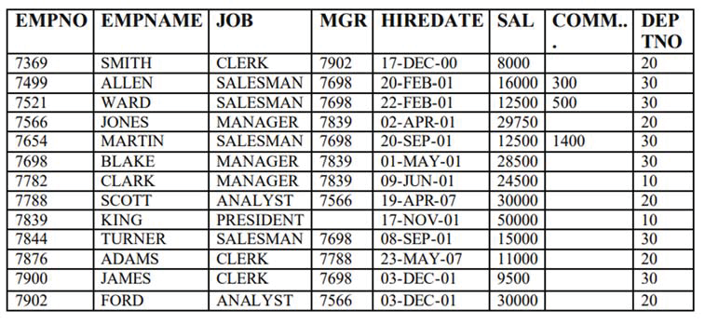  - Create collection: Department & insert data as per given table.  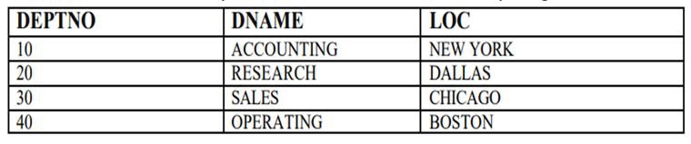  - Show all databases.  - Show currently selected database.  - Display all employee records.  - Display details of employees working as CLERK.  - Retrieve employees belonging to department number 30.  - Find employees whose salary is greater than 20000.  - Display employees whose job is SALESMAN.  - Retrieve employees who do not belong to department 10.  - Display employees with salary between 15000 and 30000.  - Find employees whose commission is not null.  - Display employees whose job is MANAGER and department is 20.  - Retrieve employees hired after 01-JAN-01.  - Display employees hired before 01-JAN-01.  - Find employees whose salary is less than or equal to 10000.  - Display employees whose name starts with ‘S’.  - Find employees whose name contains ‘AR’.  - Retrieve employees working under manager 7698.  - Display employees whose job is ANALYST or CLERK.  - Find employees who belong to either department 10 or 20.  Display only empno, empname, and salary of all employees.
22 | Prepare following collection & solve queries:  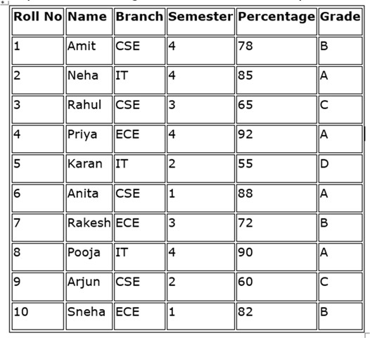  - Display all documents from the student collection.  - Retrieve details of students belonging to the IT branch.  - Find students whose percentage is greater than 75.  - Display students who are in semester 3.  - Retrieve students having grade = ‘A’.  - Display only name and branch of all students.  - Find students whose percentage is less than 60.  - Display students from CSE branch and semester 4.  - Retrieve students whose percentage lies between 65 and 85.  - Find students who are not from ECE branch.  - Display student records sorted by percentage in ascending order.  - Display student records sorted by name in descending order.  - Retrieve top 5 students based on percentage.  - Find students whose name starts with letter ‘A’.  - Find students whose name contains ‘ra’.  - Display students who belong to either CSE or IT branch.  - Retrieve students who are neither in semester 1 nor semester 2.  - Display only roll number, name, and percentage (exclude _id).  - Find students whose percentage is greater than or equal to 90.  Retrieve students whose grade is not equal to ‘D’.
23 | - Create a database named “mydb”  - Show all databases.  - Show currently selected database.  - Create a collection named “emp”.  - Show all collections of selected database.  - Insert following documents in emp collection:  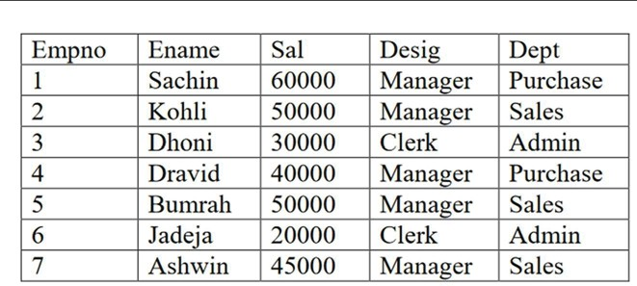  Find()  - List all documents.  - List all documents with formatted output.  - List the document of employee whose name is “achin”  - List the documents of employee whose salary is less than 30000  - List employees whose designation is manager and  - department is sales.  - List employees whose salary is less than 50000 and designation is manager or department is admin.  - Arrange the records by name in descending order.  - List first 3 documents of emp collection.  - Skip first 3 documents of emp collection.  - List 3rd and 4th documents of emp collection.  - Count no. of employees.  - List distinct designation.  Aggregate()  - Calculate annual salary of employees  - Display no. of employees designation wise.  - Display total salary of employees department wise.  - Display employee whose salary is highest.  - List highest salary of the employee department wise.  Calculate total salary of employees department wise and list whose total is greater than 70000.

1. Write a PL/SQL block that find:
1. Area of Circle
2. Area of Rectangle
3. Circumference of Circle

SET SERVEROUTPUT ON;

DECLARE
pi CONSTANT NUMBER(9,7) := 3.1415927;
r NUMBER := 5;
len NUMBER := 10;
wid NUMBER := 6;

area_circle NUMBER;
area_rectangle NUMBER;
circumference NUMBER;

BEGIN
area_circle := pi * r * r;
circumference := 2 * pi * r;
area_rectangle := len * wid;

DBMS_OUTPUT.PUT_LINE('------RESULT------');
DBMS_OUTPUT.PUT_LINE('Radius : ' || r);
DBMS_OUTPUT.PUT_LINE('Area of Circle : ' || area_circle);
DBMS_OUTPUT.PUT_LINE('Circumference of Circle : ' || circumference);
DBMS_OUTPUT.PUT_LINE('Length : ' || len);
DBMS_OUTPUT.PUT_LINE('Width : ' || wid);
DBMS_OUTPUT.PUT_LINE('Area of Rectangle : ' || area_rectangle);

END;
/
Output:
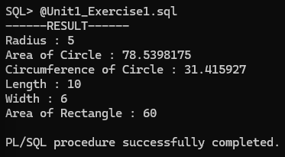
2. Write a PL/SQL block to accept product name, quantity and price from user and calculate discount.
SET SERVEROUTPUT ON;

DECLARE
p_name VARCHAR2(20);
qty NUMBER;
price NUMBER;
discount NUMBER;
total NUMBER;
final_total NUMBER;

BEGIN
p_name := '&p_name';
qty := &qty;
price := &price;
discount := &discount;

total := qty * price;
final_total := total - (total * discount / 100);

DBMS_OUTPUT.PUT_LINE('Product Name : ' || p_name);
DBMS_OUTPUT.PUT_LINE('Quantity : ' || qty);
DBMS_OUTPUT.PUT_LINE('Price : ' || price);
DBMS_OUTPUT.PUT_LINE('Total Amount : ' || total);
DBMS_OUTPUT.PUT_LINE('Discount : ' || discount || '%');
DBMS_OUTPUT.PUT_LINE('Final Amount : ' || final_total);

END;
/
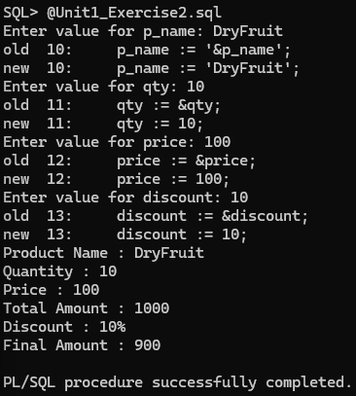
3. Write a PL/SQL block which displays gross salary of employees as per user input EID. (Consider EMP table with EID, EName, Deptno, Deptname Gender, Age, BasicSal) with appropriate data types.) Gross_Salary: BASICSAL + (DA + HRA + Medical) – PF. Rules: HRA = 15% of basic, DA = 50% of basic, Medical = Rs. 500, PF = 10% of basic.
CREATE TABLE EMP(
EID NUMBER(5) PRIMARY KEY,
ENAME VARCHAR2(20),
DEPTNO NUMBER(5),
DEPTNAME VARCHAR2(20),
GENDER VARCHAR2(10),
AGE NUMBER(3),
BASICSAL NUMBER(8)
);

INSERT INTO EMP
VALUES(101,'John',10,'IT','Male',22,30000);

COMMIT;

SET SERVEROUTPUT ON;

DECLARE
id EMP.EID%TYPE;
eno NUMBER;

name EMP.ENAME%TYPE;
basic EMP.BASICSAL%TYPE;

hra NUMBER;
da NUMBER;
medical NUMBER := 500;
pf NUMBER;
gross NUMBER;

BEGIN
eno := &eno;

SELECT EID,ENAME,BASICSAL
INTO id,name,basic
FROM EMP
WHERE EID=eno;

hra := basic * 15 / 100;
da := basic * 50 / 100;
pf := basic * 10 / 100;

gross := basic + hra + da + medical - pf;

DBMS_OUTPUT.PUT_LINE('Employee Id : ' || id);
DBMS_OUTPUT.PUT_LINE('Employee Name : ' || name);
DBMS_OUTPUT.PUT_LINE('Basic Salary : ' || basic);
DBMS_OUTPUT.PUT_LINE('Gross Salary : ' || gross);

END;
/
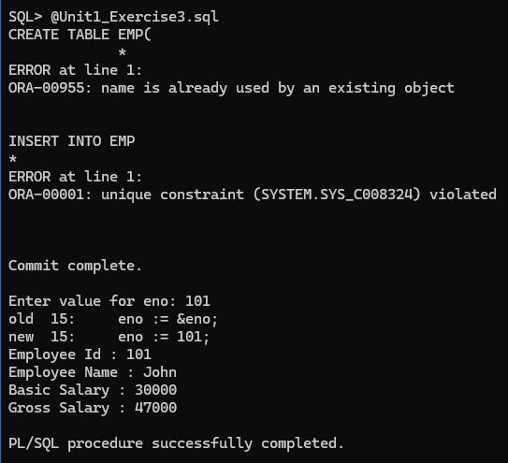
4.
1. Write a program that prints value 1 to 100 numbers using FOR LOOP.
SET SERVEROUTPUT ON;

BEGIN

FOR i IN 1..100 LOOP
DBMS_OUTPUT.PUT_LINE(i);
END LOOP;

END;
/
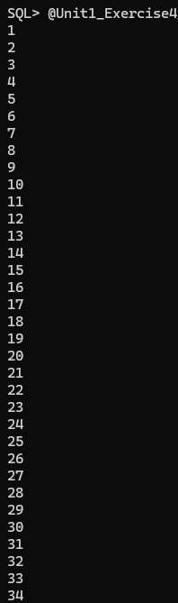
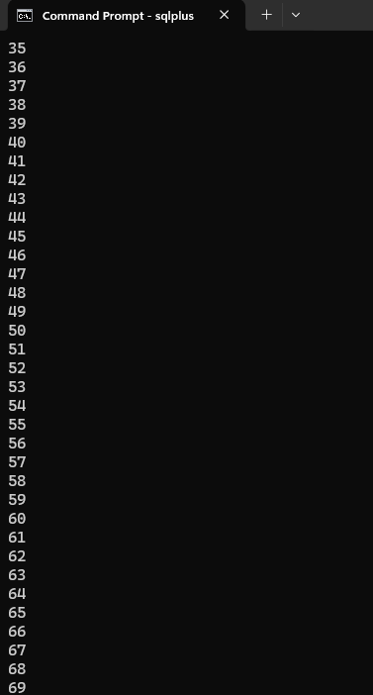
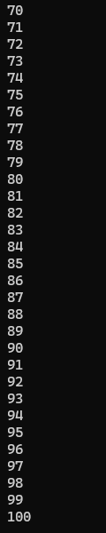

2. Write a program that prints value 1 to 100 number using LOOP Command.
SET SERVEROUTPUT ON;

DECLARE
i NUMBER := 1;

BEGIN

LOOP

DBMS_OUTPUT.PUT_LINE(i);

i := i + 1;

EXIT WHEN i > 100;

END LOOP;

END;
/

3. Write a program that prints value 1 to 100 number using WHILE LOOP.
SET SERVEROUTPUT ON;

DECLARE
i NUMBER := 1;

BEGIN

WHILE i <= 100 LOOP

DBMS_OUTPUT.PUT_LINE(i);

i := i + 1;

END LOOP;

END;
/

5.
Write a PL/SQL block to calculate the square and cube of the given number.
SET SERVEROUTPUT ON;

DECLARE
num NUMBER;
square NUMBER;
cube NUMBER;

BEGIN
num := &num;

square := num * num;
cube := num * num * num;

DBMS_OUTPUT.PUT_LINE('Number : ' || num);
DBMS_OUTPUT.PUT_LINE('Square : ' || square);
DBMS_OUTPUT.PUT_LINE('Cube : ' || cube);

END;
/
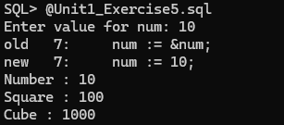

6.
Write a PL/SQL block which accepts measurement in feet and displays it in cm, inch and meter.
SET SERVEROUTPUT ON;

DECLARE
feet NUMBER;
cm NUMBER;
inch NUMBER;
meter NUMBER;

BEGIN
feet := &feet;

cm := feet * 30.48;
inch := feet * 12;
meter := feet * 0.3048;

DBMS_OUTPUT.PUT_LINE('Feet : ' || feet);
DBMS_OUTPUT.PUT_LINE('Centimeter : ' || cm);
DBMS_OUTPUT.PUT_LINE('Inch : ' || inch);
DBMS_OUTPUT.PUT_LINE('Meter : ' || meter);

END;
/
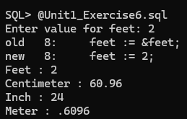

7.
Write a PL/SQL block which converts temperature from Celsius to Fahrenheit.
SET SERVEROUTPUT ON;

DECLARE
celsius NUMBER;
fahrenheit NUMBER;

BEGIN
celsius := &celsius;

fahrenheit := (celsius * 9 / 5) + 32;

DBMS_OUTPUT.PUT_LINE('Temperature in Celsius : ' || celsius);
DBMS_OUTPUT.PUT_LINE('Temperature in Fahrenheit : ' || fahrenheit);

END;
/
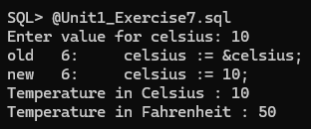
8.
Write a PL/SQL block to delete the record of employee for given EID.
SET SERVEROUTPUT ON;

DECLARE
empid NUMBER;
BEGIN
empid := &empid;

DELETE FROM EMP
WHERE EID = empid;

IF SQL%ROWCOUNT > 0 THEN
DBMS_OUTPUT.PUT_LINE('Employee record deleted successfully.');
ELSE
DBMS_OUTPUT.PUT_LINE('Employee not found.');
END IF;
END;
/
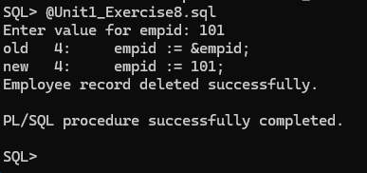
9.
Write a PL/SQL block that calculates the simple interest based on given principal amount, rate of interest and number of years.
SET SERVEROUTPUT ON;

DECLARE
principal NUMBER;
rate NUMBER;
years NUMBER;
interest NUMBER;
BEGIN
principal := &principal;
rate := &rate;
years := &years;

interest := (principal * rate * years) / 100;

DBMS_OUTPUT.PUT_LINE('Principal Amount : ' || principal);
DBMS_OUTPUT.PUT_LINE('Rate : ' || rate);
DBMS_OUTPUT.PUT_LINE('Years : ' || years);
DBMS_OUTPUT.PUT_LINE('Simple Interest : ' || interest);
END;
/
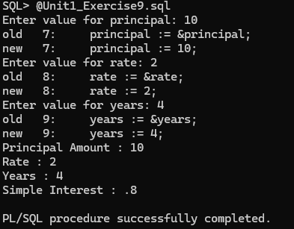
10.
Write a PL/SQL block which displays gross salary of employees as per
user input EID. (Consider EMP table with EID, EName, Deptno,
Deptname Gender, Age, BasicSal) with appropriate data types.)
Gross_Salary: BASICSAL + (DA + HRA + Medical) – PF. Rules: HRA =
15% of basic, DA = 50% of basic, Medical = Rs. 500, PF = 10% of
INSERT INTO EMP
VALUES(101,'John',10,'IT','Male',22,30000);

COMMIT;

SET SERVEROUTPUT ON;

DECLARE
emp_id EMP.EID%TYPE;
emp_name EMP.ENAME%TYPE;
basic EMP.BASICSAL%TYPE;

eid NUMBER;

hra NUMBER;
da NUMBER;
medical NUMBER := 500;
pf NUMBER;
gross NUMBER;

BEGIN
eid := &eid;

SELECT EID, ENAME, BASICSAL
INTO emp_id, emp_name, basic
FROM EMP
WHERE EID = eid;

hra := basic * 15 / 100;
da := basic * 50 / 100;
pf := basic * 10 / 100;

gross := basic + hra + da + medical - pf;

DBMS_OUTPUT.PUT_LINE('Employee Id : ' || emp_id);
DBMS_OUTPUT.PUT_LINE('Employee Name : ' || emp_name);
DBMS_OUTPUT.PUT_LINE('Basic Salary : ' || basic);
DBMS_OUTPUT.PUT_LINE('HRA : ' || hra);
DBMS_OUTPUT.PUT_LINE('DA : ' || da);
DBMS_OUTPUT.PUT_LINE('Medical : ' || medical);
DBMS_OUTPUT.PUT_LINE('PF : ' || pf);
DBMS_OUTPUT.PUT_LINE('Gross Salary : ' || gross);

END;
/
